NCI/CBIIT

GreenSheets System
Use-Case Specification: View and Manage a greensheet

Version 1.6

Prepared for:
The National Institutes of Health
National Cancer Institute
CBIIT

Document Location
Ensure that this document is current. Printed documents and locally copied files may become obsolete due to changes to the master document. The source of this document is located in the Subversion SVN documentation repository at: https://ncisvn.nci.nih.gov/svn/iscs/greensheets/Requirements/Use-cases/View%20and%20Manage%20a%20greensheet%20use-case.doc

Revision History
Version Number | Revision Date | Author | Summary of Changes
1.0 | 8/15/2016 | G. Tulchinskaya | Existing requirements that came from analysis phase of the project
1.1 | 8/16/2016 | G. Tulchinskaya | Changes for re-design (JIRA ticket GREENSHEET-522)
1.2 | 9/13/2016 | G. Tulchinskaya | Added sec. Additional Requirements => Navigation
1.3 | 11/29/2016 | G. Tulchinskaya | Added references to active urls in sec. “UI elements and rules” => Questionnaire
1.4 | 12/08/2016 | G. Tulchinskaya | Updated sec. “UI elements and rules” (links to IMS, FCOI and FACTS, and radio buttons with single answer)
1.5 | 1/17/2017 | G. Tulchinskaya | Updated sec. “UI elements and rules” => Submit button
1.6 | 3/28/2017 | G. Tulchinskaya | Updated sec. USER INTERFACE => UI elements and rules => Questionnaire => Answers column (string length 250 characters)

Reference Documents
Document Name | SVN Location
GreenSheets Re-design Project Scope | https://ncisvn.nci.nih.gov/svn/iscs/greensheets/Requirements/Specs/GreenSheets%20Redesign%20Project%20Scope.docx
Print a greensheet use-case | https://ncisvn.nci.nih.gov/svn/iscs/greensheets/Requirements/Use-cases/Print%20a%20greensheet%20use-case.doc
Form Builder – scope of changes.docx | https://ncisvn.nci.nih.gov/svn/iscs/greensheets/Requirements/Specs/Form%20Builder%20-%20Scope%20of%20changes.docx

Key terms
Refer to GreenSheets Re-design Project Scope

Table of Contents

1. SUMMARY 4
1.1 Brief Description 4
1.2 Actor(s) 4
1.3 Goal(s) 4
2. USE-CASE DIAGRAMS 4
3. PRE-CONDITION(S) 4
3.1 Navigate 4
4. FLOWS OF EVENTS 5
4.1 Basic flow: View a greensheet 5
4.2 Alternative flows 6
4.2.1 Edit and Save a greensheet 6
4.2.2 Submit a greensheet 9
4.2.3 Manage Attachment(s) 11
4.3 Exception Flows 14
5. POST-CONDITIONS 15
5.1 Post-conditions upon Success 15
5.1.1 Greensheet is displayed 15
5.1.2 Greensheet is edited and saved 15
5.1.3 Greensheet is submitted 15
5.1.4 Attachment(s) are displayed/added/deleted/copied 15
5.2 Post-Conditions upon Failure 15
5.2.1 System error 15
5.2.2 Post-Condition upon Failure Two 15
6. EXTENSION POINTS 15
6.1 Print a greensheet 15
7. BUSINESS RULES and Corresponding Errors 15
8. Warning messages table 15
9. Information messages table 15
10. USER INTERFACE 16
10.1 Program greensheet 16
10.2 Specialist greensheet 17
10.3 UI elements and rules 17
11. Additional requirements 24
11.1 Navigation 24

SUMMARY

Brief Description
This use-case describes functionality allowing Actor to view and/or manage a questionnaire (known as a greensheet) for a specific grant.

Actor(s)
- Program Director (PD)
- Program Analyst (PA)
- Diversity supplement PD
- Grants Management Specialist (Specialist)
- Guest
For details please refer to GreenSheets Re-design Project Scope, Sec. GreenSheets users => User Roles

Goal(s)
- View greensheet(s)
- Edit and Save a greensheet
- Submit a greensheet
- Manage attachment(s) for a selected question

USE-CASE DIAGRAMS
Please refer to GreenSheets Re-design Project Scope,
- sec. Diagrams => User (real person) functionality
- sec. Diagrams => Workflow/Statuses diagrams within Greensheets system – change for re-design

PRE-CONDITION(S)

Navigate
Actor navigated to a greensheet in one of the following ways:
Actor | From the system
PD/PA/ Diversity supplement PD | - Notifications => see GreenSheets Re-design Project Scope, sec. Other system relationships => Notifications  - YourGrants => see GreenSheets Re-design Project Scope, sec. Other system relationships => YourGrants  - GreenSheets => from the Search/hit list screen (can only navigate to Program greensheet)
Grants Management Specialist (Specialist) | - eGrants => see GreenSheets Re-design Project Scope, sec. Other system relationships => eGrants - changes for re-design  - GreenSheets => from the Search/hit list screen  - GPMATS => see JIRA ticket GREENSHEET-524 and requirements in GreenSheets Re-design Project Scope, sec. Dependencies with other systems => Significant dependencies => GPMATS - changes for re-design
Guest | - GreenSheets => from the Search/hit list screen

FLOWS OF EVENTS

Basic flow: View a greensheet
NOTE: UI is described in this use-case, Sec. User Interface
Also refer to a diagram in GreenSheets Re-design Project Scope =>
sec. Diagrams => Workflow/Statuses diagrams within Greensheets system – change for re-design

- The system determines which questionnaire to display based on the logic below.
Greensheet Status | System behavior when user retrieves greensheet | Comments
Greensheet is in status “Not Started” | Latest version of template (latest questions) is displayed | For the rules who can edit a greensheet in “Not Started” status, see GreenSheets Re-design Project Scope  Sec. Diagrams => User (real person) functionality  And  Sec. GreenSheets users => User roles
Greensheet is in status “Submitted” and/or “Frozen” | Version of template on the moment of submission is displayed. All answers and comments are displayed in read-only mode; there is no ability to add/delete attachments. | Greensheet in status “Submitted” or “Frozen” is displayed as read-only.
Greensheet is in status “Saved” (not yet submitted) | The system checks if a new template has been promoted from Form Builder since the last save.  - If a new template HAS been promoted, then:  - Latest version of template (latest questions) is displayed.  - System will automatically match the answers/comments/attachments for the questions that did not change. (Note: partial reconciliation is NOT needed, meaning that if question did not change, but answer options are changed, we will consider it as a changed question and will NOT copy attachments and comments).  - System will display a warning message that the template has changed and instructions to a user. OGA need to provide the message text. See preliminary text in sec. Information messages table => I-001  - If a new template has NOT been promoted since the last save, then the system displays saved greensheet (questions/answers/comments/attachments).  NOTE (applicable to both scenarios): After the match is performed in the first scenario, on Save, the system creates ‘a bag’ of unmatched attachments from a prior version. The system will provide ability to copy attachments that were saved before the template has been promoted. There is no need to display related questions. See this document, alternative flow “Manage Attachment(s)”  This ‘bag’ is kept until greensheet is submitted. The user will keep ability to copy attachments from this bag until the submission of the greensheet. | Implementation note for re-design: When system automatically matches the questions, ALL sub-questions should be displayed (expanded) on the screen. This way, if top level questions were matched, and sub-question(s) did not match, the user will see the difference immediately, even before validation on submission
Greensheet is un-submitted after new module is promoted | Same as in scenario “Greensheet is in status “Saved” (not yet submitted)”

- The system provides the rest of functionality as described in GreenSheets Re-design Project Scope, Sec. GreenSheets users => User Roles

Alternative flows

View, Edit and Save a greensheet
Major functionality:
- View greensheet
- Provide an answer to a question
- Manage Attachments for a question (see this doc., sec. Additional Requirements => Attachments Rules)
- Add/edit/delete comment for a question and sub-questions (if any)
- Clear All Answers
- View All Comments
- Save
Reference | Rule name | Description
 | When to display “Save” button | For the rules when to display the Save button, please refer to this document, sec. Interfaces => UI elements and rules (SR0030-010-05, SR0030-010-11)
DR0030-010-04 | Clear All Answers | When user clicks Clear All Answers button, the system displays the warning message  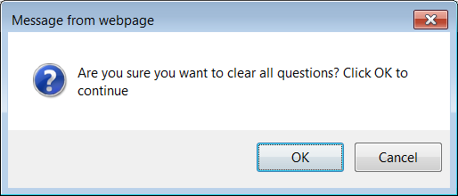  If user selects this option, system will request confirmation by displaying the following message:  Are you sure you want to clear all questions? Click OK to continue  - If user selects "OK", system will reset all answers to all questions on the form to blank unanswered state, and remove all comments. It will "collapse" all sub-questions that may have been unfolded. After that, user will be able to start over with filling out the form. NOTE: attachments are NOT deleted.  - If user selects "Cancel", system will do nothing and user will continue to interact with the greensheet form.
DR0030-010-05 | Validations on Save | a) If user selects this option, system will perform validation of responses. System will allow the user to save a form that he or she only partially filled out (i.e., leaving questions with blank answers), but it will not allow invalid responses (such as a date that does not exist).  Specifically, system will validate that answers user provided meet the following rules:  - Comment. Response of this type should not exceed 4000 characters in length.  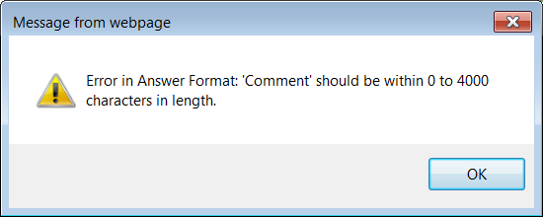  - Multi-line text field. Response of this type should not exceed 2000 characters in length. 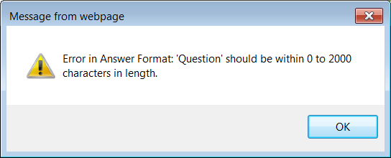  - Text string. Response of this type should not exceed 200 characters in length.  - Number. Value entered should be in fact numeric. The only non-numeric characters allowed are "+", "-", and "." "+" and "-" can only occur at the beginning of the entered value.  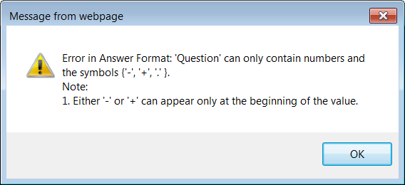  - Date. Value entered should evaluate to a valid, existing date.  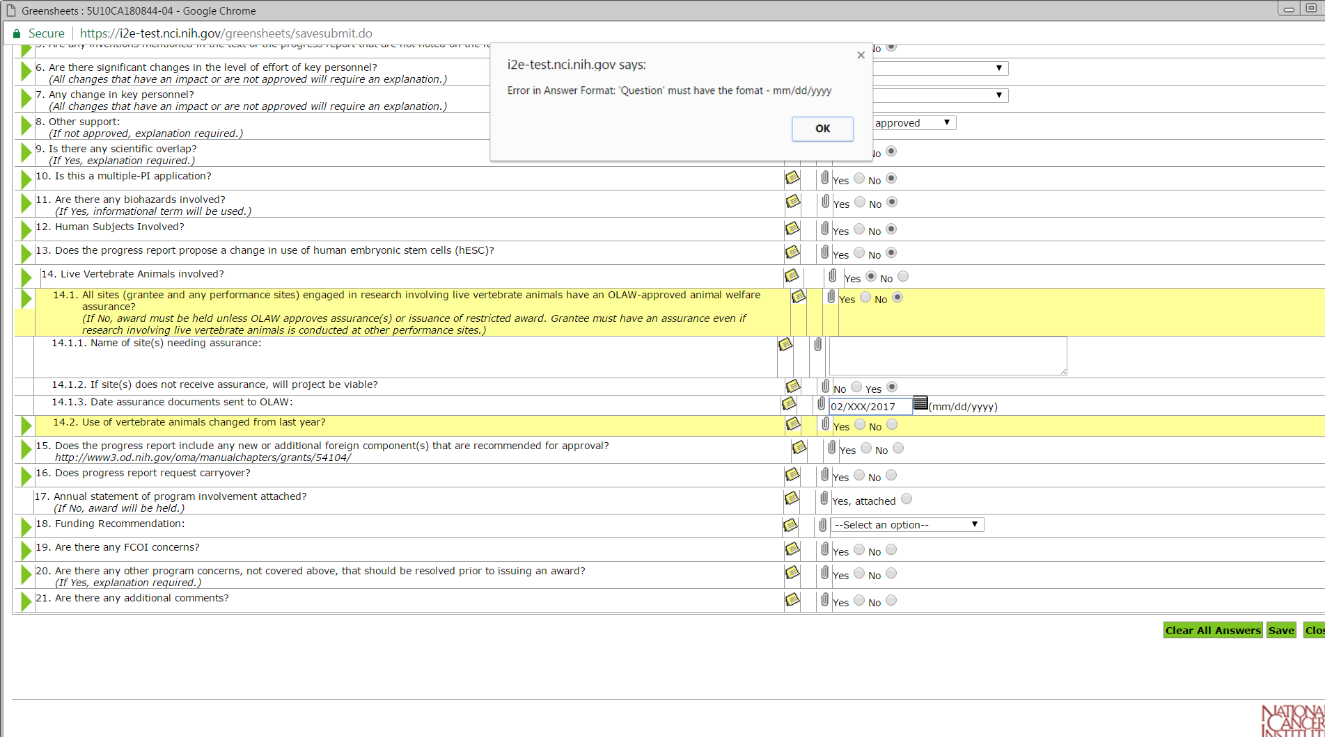  - Display the following error message in a pop-up window:  "The form cannot be saved since the data format for some answers may not be correct. The exclamation marks indicate the answer(s) that are not correct. Please check the answers and try saving the form again".  NOTE: Individual error messages are displayed as pop-up text when hovering over the exclamation marks with the mouse.  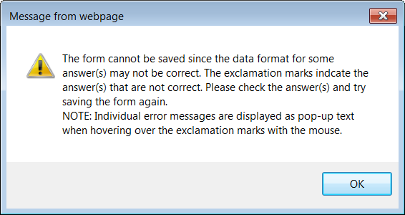  ii) After user dismisses the pop-up window with the error message, system will update the greensheet form screen, displaying an alert image (!) to the left of every question that failed validation. System will provide an error message, specific to the problem with each individual question that failed validation, to be displayed when user hovers the mouse pointer over the alert image.  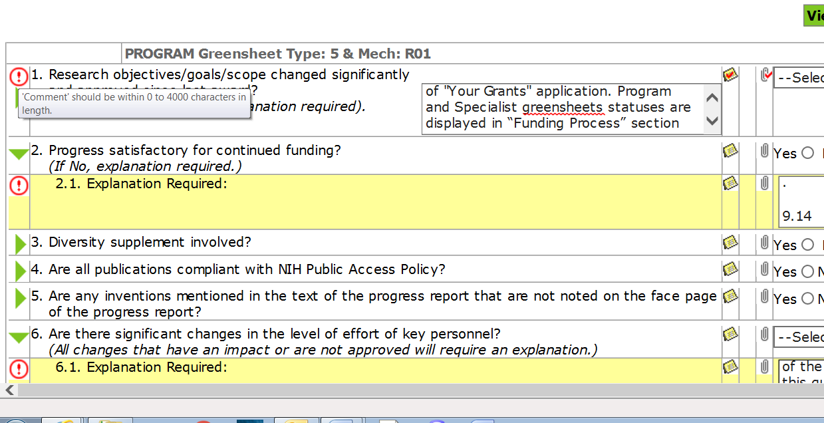  iii) User will be able to resume interacting with the greensheet form screen and make corrections to the answers.  b) If all responses pass validation, system will store the responses (including changes to file attachments, if any) in the database.
 | Status “Saved” | When Greensheet is saved, the status is set to “Saved”. On the hit list a greensheets in “Saved” status is marked with “S” icon next to “G”.
 | Record last updated date/time and user_id | On save, the system records last updated date/time and user_id

Submit a greensheet
Reference | Rule name | Description
 | When to display “Submit” button | For the rules when to display the Submit button, please refer to this document, sec. Interfaces => Greensheet screen form UI (SR0030-010-06, SR0030-010-12)
 | Visual indication when PD greensheet can be submitted | NOTE: changes to the text in this section will be done after UI re-design. Please refer to Greensheet-538 - Resolve Greensheets Submission complains  System will allow or not allow users to SUBMIT Program type of greensheets for a grant depending on whether the grant is "on control". This means that system will verify existence of a grant record in GPMATS' database. Program greensheets for such grant have asterisk * next to the greensheet “G” icon on the screen. This * is displayed based on users permission to submit the greensheet of this type for this grant. (For additional information about icons see GreenSheets Redesign Project Scope, sec. Interfaces => Icon Glossary => Greensheet Status Icons)  Example:
  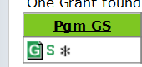 | Program director will see * only next to PD greensheet for the grant assigned to her/him
  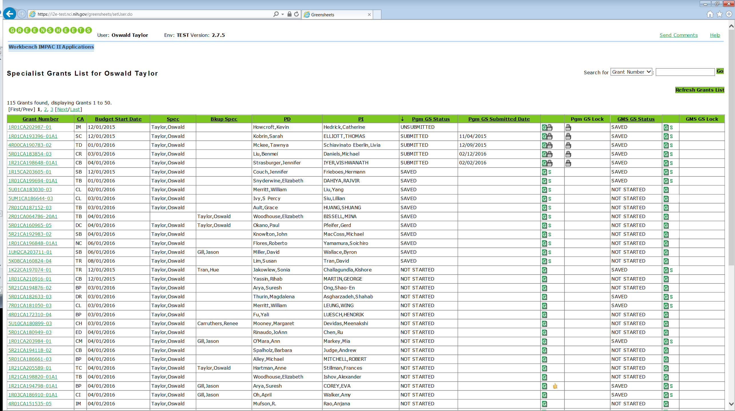 | Guest user/GMS/Program Analyst will not see * for the same PD greensheet because these users have no rights to submit PD greensheet for this grant.
   | Asterisk * is NOT displayed for GMS.
DR0030-010-06 | Overall validations on Submit | If user selects this option, system will:  a) Validate that responses satisfy the following rules:  i) All rules checked when saving the form – For details see Save option DR0030-010-05.  - ii) No blank responses. Submission of the form will be only allowed when all questions displayed on the form have been answered. (This means that some sub-questions defined for the form in questions definition source file will not be displayed because user did not choose an answer to higher-level question with which those sub-questions are associated. As they are not displayed, responses to those questions are, obviously, not required.)  Special case: A question without any answer options can be promoted from Form Builder. In such case, validations on Submit should skip such question. See example below (last question).  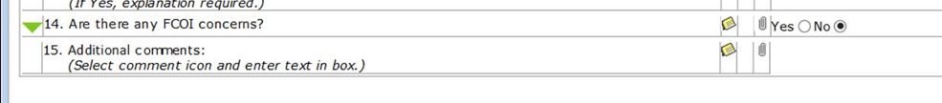  - Validations from Form Builder: GSFB passes validation rules within XML file. GS processes XML and insert client side validation into the HTML Blob stored in the database  If responses do not pass validation, system will:  i) ) Display an error message in a pop-up window:  "The form cannot be submitted due to the following reason(s):  1. The data format for some answers may not be correct.  2. Some questions require answers.  Note 1: The exclamation marks indicate the answer(s) that are not correct. Please check the answers and try saving the form again.  Note 2: Individual error messages are displayed as pop-up text when hovering over the exclamation marks with the mouse.  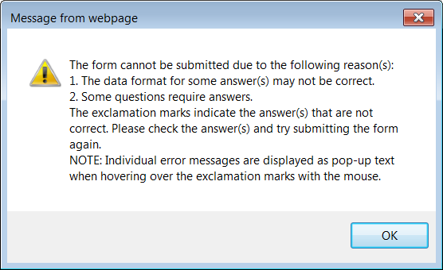  ii) After user dismisses the pop-up window with the error message, system will update the greensheet form screen, displaying an alert image (!) to the left of every question that failed validation. System will provide an error message, specific to the problem with each individual question that failed validation, to be displayed when user hovers the mouse pointer over the alert image.  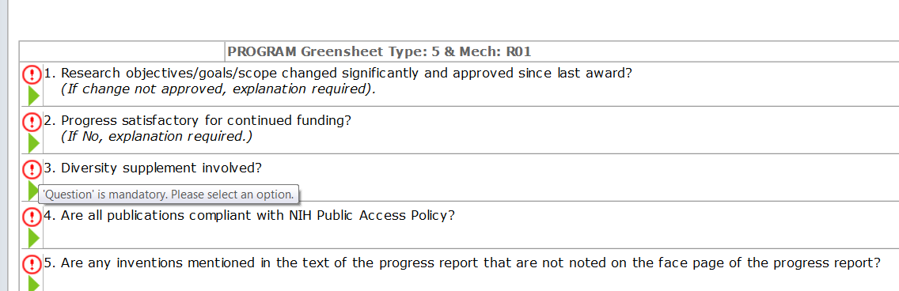  iii) User will be able to resume interacting with the greensheet form screen and make corrections to the answers.  b) If all responses pass validation, system will:  - store those responses (including changes to attachments if user made any) in the database,  - and change the status of the greensheet in the database to "SUBMITTED". Greensheet in status “Submitted” is not editable.  - Saves the date of submission (it is displayed on Specialist view). NOTE: The submitted_date is saved as a Date Oracle type winch includes year, month, day, hour, min, and seconds. It does not store fractures of seconds. We can use data (with time) later in the reporting.  - NOTE: “Locked” icon will be displayed next to greensheet in “Submitted” status in all appropriate views (e.g. when PD is searching by PI name, or on GMS or guest view).  c) System will remove from the screen all questions and answers of the greensheet form, and replace them with confirmation screen displaying the message:  "The Greensheet Form for Grant <grant number> has been submitted"  For additional information see this document, sec. “Navigation”
 | Validations on Submit for individual questions | Every parent question displayed on a greensheet must have an answer on Submission.  Parent question might have a sub-question. Sub-question(s) are displayed or not based on the answer to a parent.  If sub-question(s) are displayed, the answer to each displayed sub-question is required on Submission.  For additional information see this document, sec. “Import templates from GS Form Builder”

Manage Attachment(s)
- User requests to manage attachments for a specific question by clicking attachment icon for this question
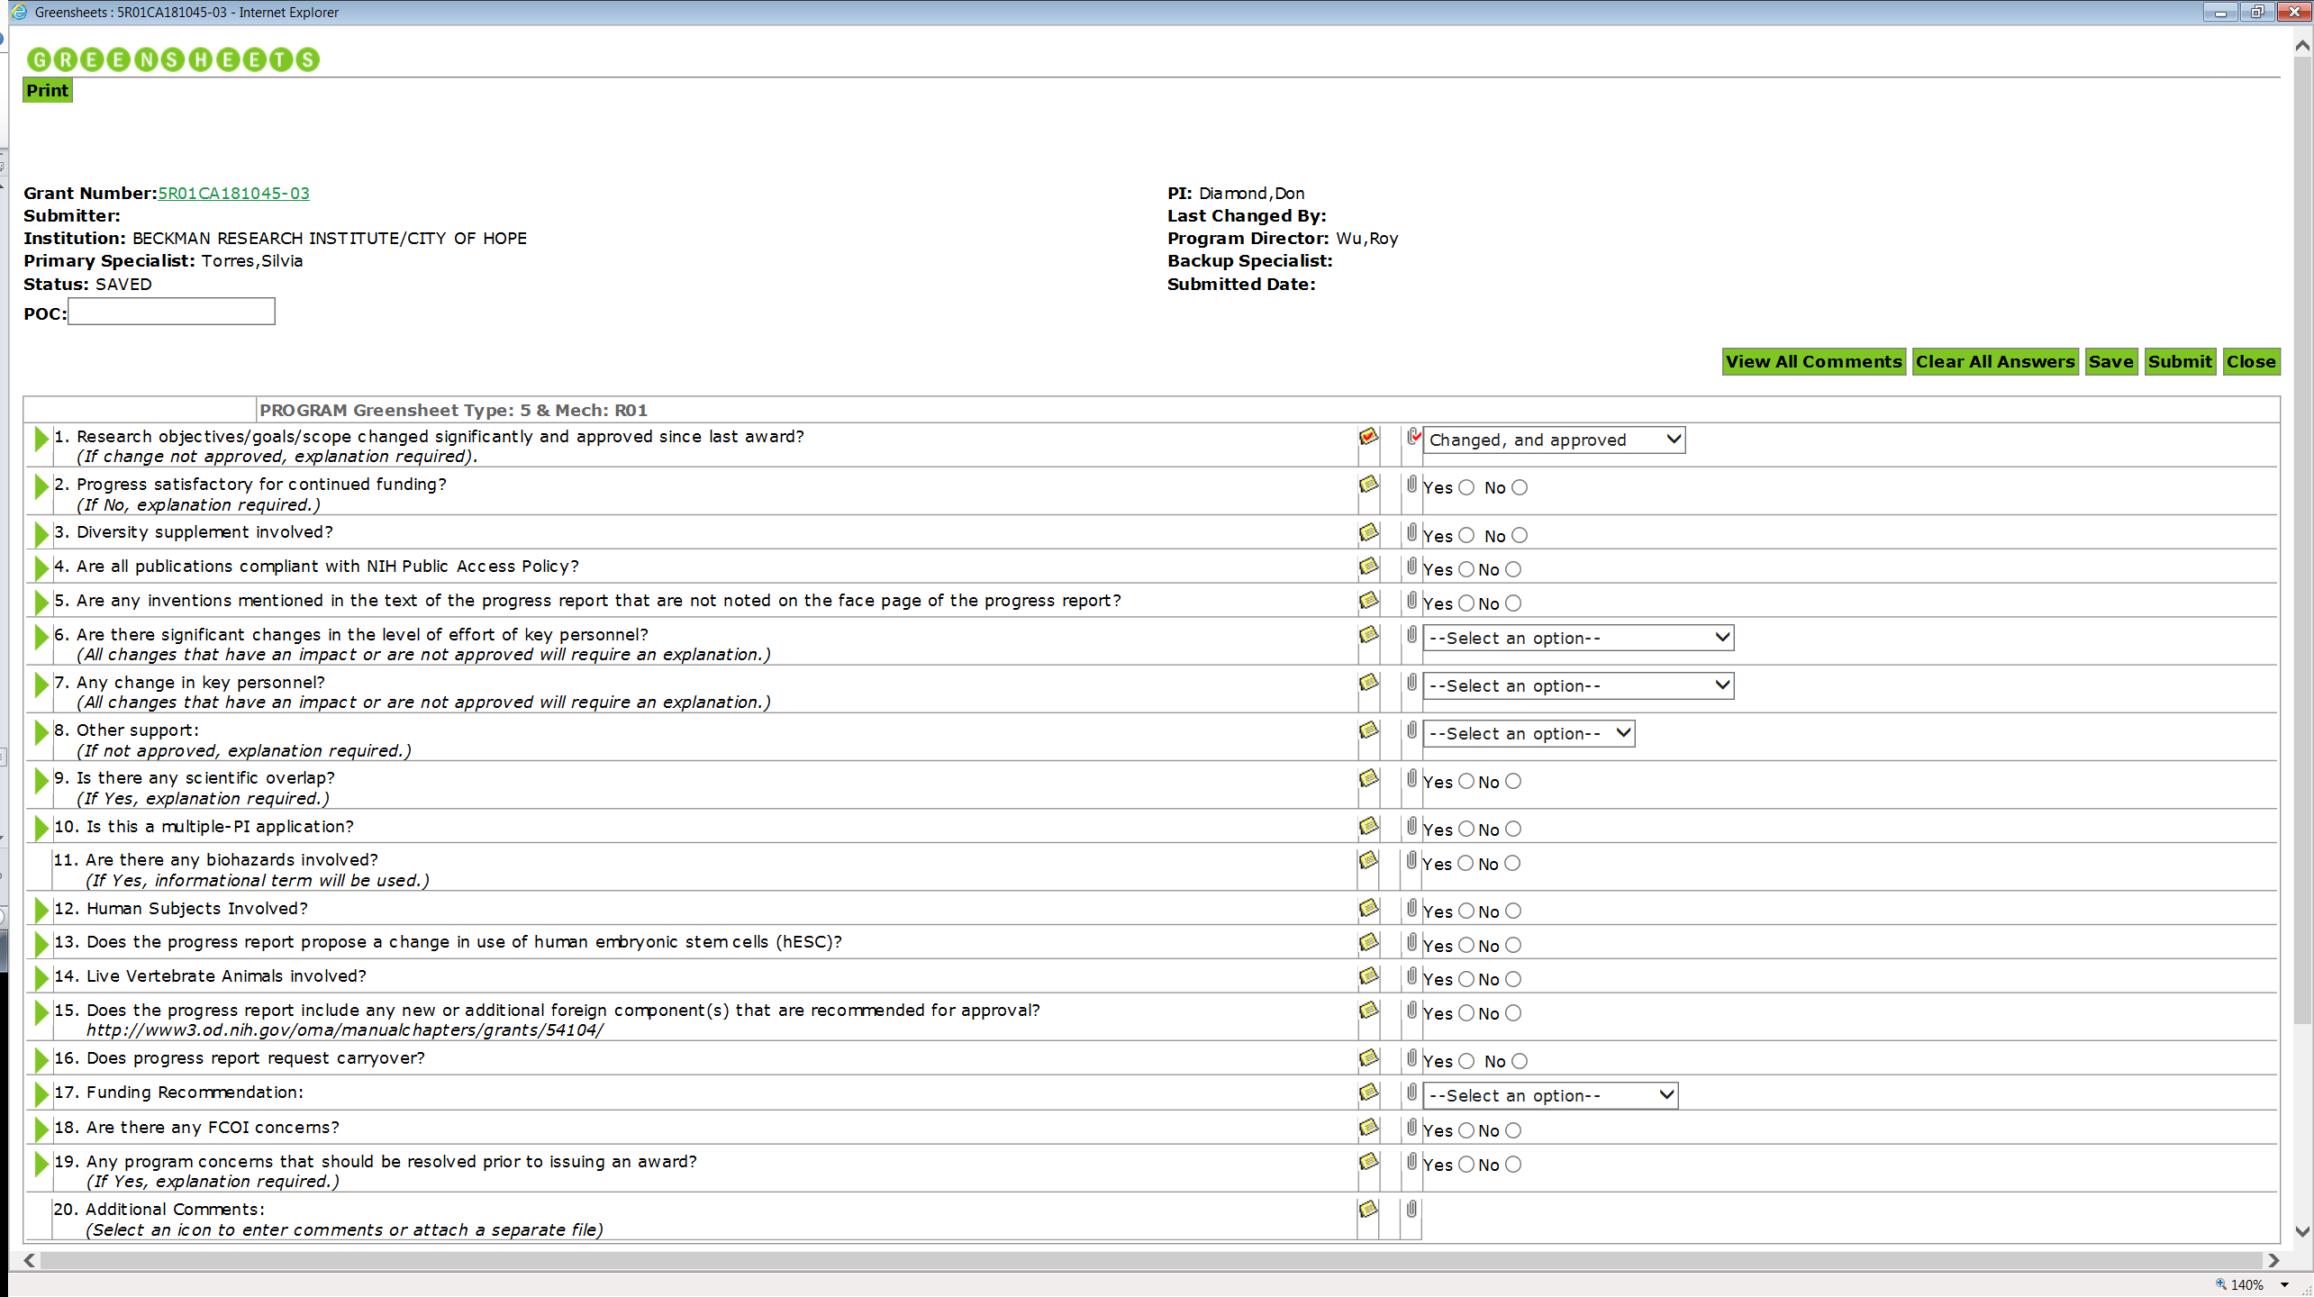
- The system opens a “New Attachment” window. If any attachment(s) already exist for this question, they are displayed on the list in “Attachment File List” section.
Figure 1: Before re-design
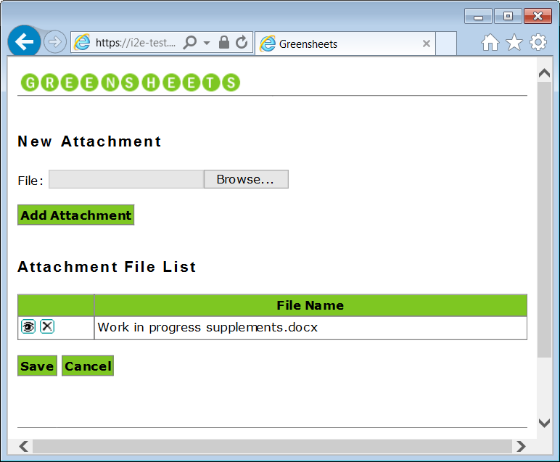
Figure 2: Mockup for re-design
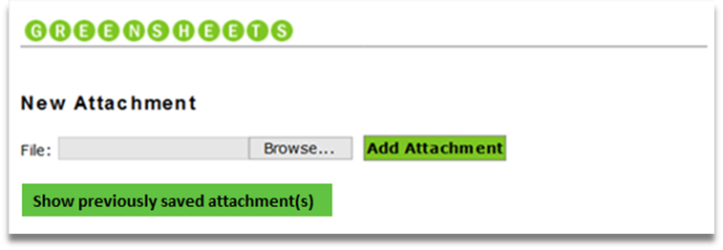
Attachment File List
File Name | Action
Attachment name 1.docx | Delete

NOTE: “Show previously saved attachment(s)” button should be displayed only if any unmatched attachment(s) exist. For details see GreenSheets Re-design Project Scope =>
Sec. Diagrams => Workflow/Statuses diagrams within Greensheets system – change for re-design
Sec. Form Builder template versioning and GS system behavior – change for re-design
- Actor can request to:
  - View attachment on the file list => the system provides the options to Open/Save/Cancel
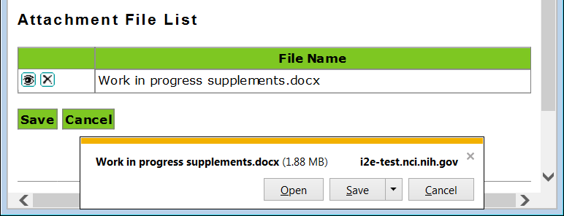
  - Delete attachment from the file list => the system displays a warning: “Are you sure you want to delete attachment?”. Options are OK and Cancel. If Actor clicks OK, attachment is no longer displayed in the attachment file list. Proceed to step “Actor requests to Save or Cancel the changes”
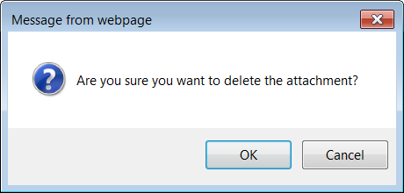
  - View and copy attachments from a ‘bag’ of previously saved attachments (by clicking “Show previously saved attachment(s)” button) =>
    - The system displays unmatched attachment(s) and provides ability to view and copy them

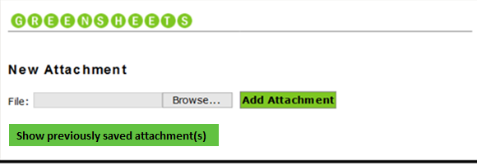
Unmatched attachment(s):
File Name | Action
Email PDF1.pdf | Copy
Doc3333.doc | Copy

Attachment File List
File Name | Action
Attachment name 1.docx | Delete

    - Actor requests to copy selected document from the list of unmatched attachments
    - The system displays selected attachment in “Attachment File List” section. Proceed to step “Actor requests to Save or Cancel the changes”
  - Add attachment to the file list =>
    - Actor locates the file on his/her local machine (by clicking Browse button)
    - Actor requests to Add Attachment
    - The system displays selected attachment in “Attachment File List” section. Proceed to step “Actor requests to Save or Cancel the changes”
  - Actor requests to Save or Cancel the changes
    - If Actor requests to Cancel the changes to the attachment file list, the system will close the window and no changes are saved. Use-case ends

    - If Actor requests to Save the changes to the attachment file list, the system will:
      - Save the changes to the attachment list for this question
      - Close attachment window
      - Refresh the greensheet screen. If there are no attachments for this question, the system displays - Icon; if there is at least one attachment for this question, the system displays - Icon
      - If user selects and use the attachment from the “bag” of unmatched attachments, selected attachments should be removed from the “bag” on save
      - Use-case ends.
Reference | Description | Error/Warning
SR0040-010 | The name of the file user tries to attach to the same question must be unique. | On click of “Add Attachment” button the system displays and error message (pop up)  A file with the specified name already exists. Please rename the file before attempting to attach
SR0040-010 | If user tries to attach to a particular question a file whose name matches name(s) of files attached to a different question on the same greensheet form, or to any question(s) on a form for any different grant, system will support the ability to accomplish that | n/a
Max file size | The size must be at most 10MB  Max size is set in greensheetsconfig.properties in the property file.attachment.size.limit | Error text:  The File you are attaching is too large. The file must be less than <10>mb.  NOTE: The value in <> will change depending on the limit that is set in greensheetsconfig.properties
File for attachment has not been selected | If Actor clicked “Add Attachment” button in attachment popup without selecting the file, the system should display an error | Please select a file to attach

Exception Flows
Refer to sec. “BUSINESS RULES and Corresponding Errors” in this document

POST-CONDITIONS

Post-conditions upon Success

Greensheet is displayed

Greensheet is edited and saved

Greensheet is submitted

Attachment(s) are displayed/added/deleted/copied

Post-Conditions upon Failure

System error
Refer GreenSheets Re-design Project Scope, sec. E-mail notifications to Support Staff.

Post-Condition upon Failure Two
Upon handled errors, the system displays error messages. See this documents, sec. BUSINESS RULES and Corresponding Errors

EXTENSION POINTS

Print a greensheet
Refer to https://ncisvn.nci.nih.gov/svn/iscs/greensheets/Requirements/Use-cases/Print%20a%20greensheet%20use-case.doc

BUSINESS RULES and Corresponding Errors
Business Rules (# or Name) | Description | Corresponding Errors
Template has not been promoted | Greensheets system can bring greensheet form only when the template of this type (Program or Specialist or Revision) has been promoted for this type/mechanism combination from Form Builder.  If the template has NOT been promoted, when user clicks on “G” icon for this type of the greensheet, the system displays the information message instead of the greensheet: | Greensheet Questionnaire Not Found  Greensheet Questionnaire definition was not found for type <insert type/mech> grants.  Please contact support if you feel that greensheet questionnaires for such grants should be defined
Type of greensheet to display | When user navigates to a greensheet by clicking “G” icon, the system determines what type of greensheet is requested and displays a corresponding questionnaire header.

Warning messages table
Name | Triggering Event | Message text

Information messages table
Name | Message text
I-001 | The greensheet template has been updated and the questions might have changed. The system automatically matched the answers and attachments to the questions that did not change (if any). Please check for correctness and enter answers to the updated questions.  To copy attachment (if exists) that were saved before the template was updated, click on attachment icon on this screen for a selected question. NOTE: after submission of this greensheet, all prior attachments that were not copied will be DELETED.

USER INTERFACE

Program greensheet
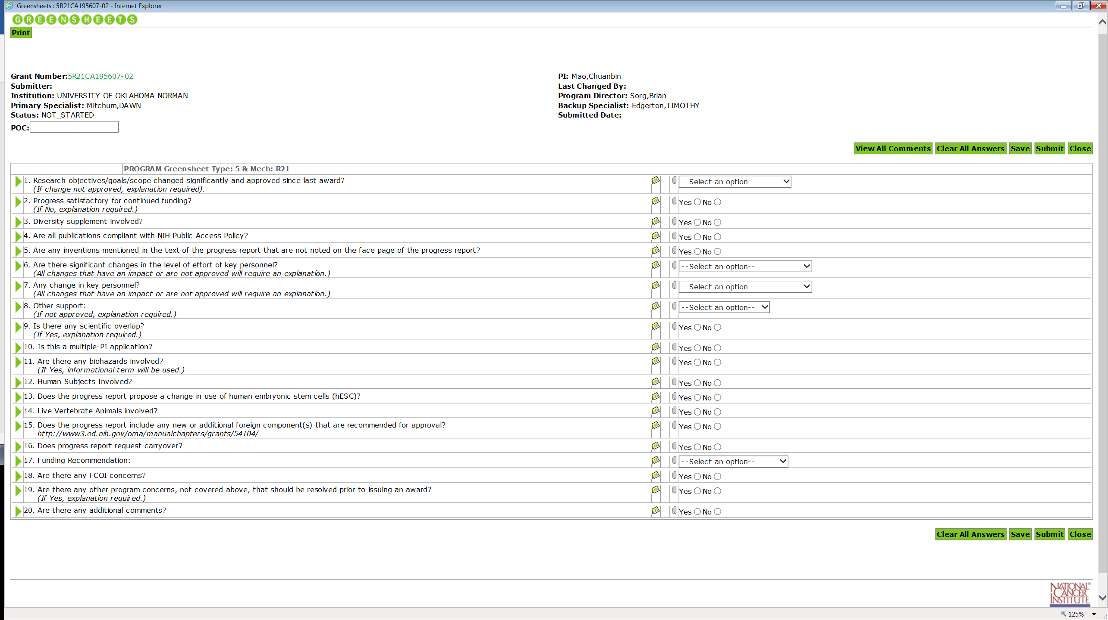

NOTE for greensheet-584: add links to IMS, FCOI and FACTS to a greentsheet

Specialist greensheet
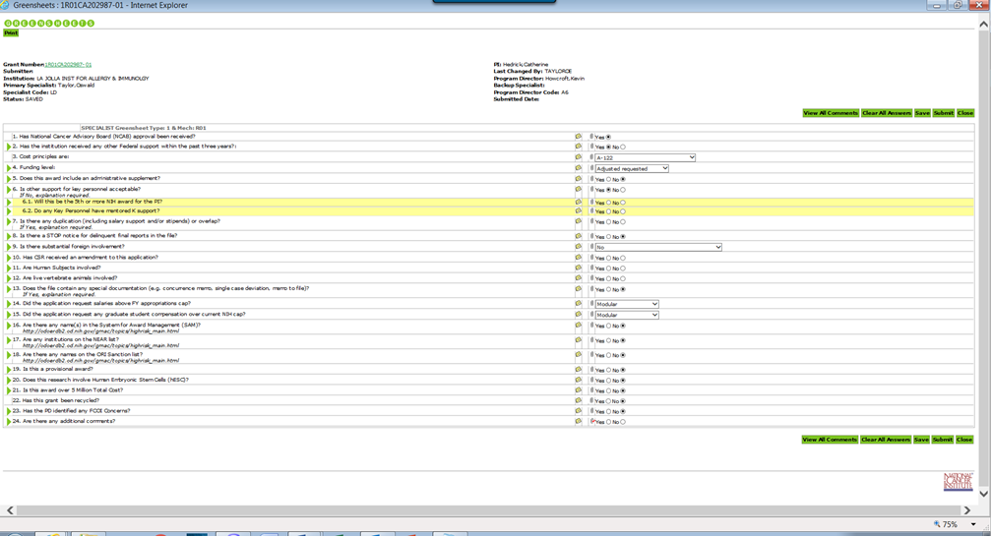
NOTE for greensheet-584: add links to IMS, FCOI and FACTS to a greentsheet

UI elements and rules
Reference | Rule name | Description
SR0030-010 | Greensheet Form Screen Generation | The system will present the following content on the greensheet form, following the rules as explained in individual requirements (SR0030-010-01 to SR0030-010-14).  - Screen Header  - Attributes of the greensheet  - View/Hide All Comments option  - Clear All Answers option.  - Save option  - Submit option.  - Close option.  - Questionnaire header  - Questionnaire  - Clear All Answers button  - Save button  - Submit button  - Close button or Back to Grant List (navigation link)  14. Links to IMS, FCOI and FACTS (deep linking)  15. Screen footer
SR0030-010-01 | Screen Header | The system will present the screen header with the followings:  - Greensheets logo.  - Print option.
SR0030-010-02 | Attributes of the Greensheet | The system will present Attributes of the greensheet and its associated grant application, as follows:
  Label: | Description | Comments
  Grant Number: | The grant number of the grant whose greensheet is being displayed. The grant number will be represented as a hyperlink that, if selected, will open a new window with detailed grant information ("Everything you ever wanted to know about …" screen of "Your Grants" application). | Hyperlink  Blank on draft preview of greensheet
  Submitter: | User ID of the person who performed SUBMIT action. Displayed only after submission | Read-only  Blank on draft preview of greensheet
  Institution: | Institution applying for the grant | Read-only
  Primary Specialist: | Primary GM Specialist responsible for the grant (last name, first name) | Read-only
  Status: | Status of this greensheet. Possible values are NOT_STARTED, SAVED, SUBMITTED, UNSUBMITTED, FROZEN.  NOTE: during greensheet template preview, the system displays the word DRAFT. Please refer to this document, sec. Promotion or rejection of greensheets => Review Draft Greensheets pop up elements | Read-only
  POC: | Each Program greensheet can have a program point of contact specified. If an additional point of contact is desired for the greensheet it can be entered.  This field is not a required field; a greensheet can be saved and submitted without filling it in. There is no enforced format for the value to be filled in. | Displayed only on Program greensheet  Enterable field – before submission;  Read-only if the status is Submitted or Frozen  Not displayed on draft preview of program greensheet
  PI: | Principal Investigator of this grant application (last name, first name) | Read-only
  Last Changed By: | User ID of the person who performed last action (save, submit, unlock). | Read-only  Blank on draft preview of greensheet
  Program Director: | Program Director assigned to this grant (last name, first name) | Read-only
  Backup Specialist: | Backup GM Specialist responsible for the grant (last name, first name) | Read-only
  Submitted Date: | The latest date when greensheet was submitted. Format MM/DD/YYYY | Read-only  Blank on draft preview of greensheet
  Specialist Code | The two-character identifying code assigned to the Primary Specialist. | System will show this item only on Specialist greensheets.
  Program Director Code | Two-character identifying code assigned to the Program Director responsible for this grant. | System will show this item only on Specialist greensheets.
SR0030-010-03 | View All Comments button | The system will present View All Comments option (always displayed)
 | View/Hide All Comments button | After user clicked “View All Comment” button => the system should change it to “Hide All Comments” button  After user clicked “Hide All Comment” button => the system should change it to “View All Comments” button
 | View All Comments functionality | When user clicked “View All Comment” button, the system expands all comments fields where comments were entered (marked by )  Row(s) where comments were not entered are NOT expanded
 | Hide All Comments functionality | When user clicked “Hide All Comment” button, the system collapses all comments fields
SR0030-010-04 | Clear All Answers button | The system will present this option only if it also displays the Save button according to rules explained in Save button - UC0030-010-05 (i.e., if the user is allowed to make changes to answers)
SR0030-010-05 | Save button | The system will display Save button only if:  - The greensheet is a program greensheet, the user is a Program Director who is the official NCI Program Director for this grant (of whom there is always only one for each grant), and the greensheet's status is NOT_STARTED or SAVED or UNSUBMITTED  OR  - The greensheet is a program greensheet, the user is a different Program Director than this grant's Program Director, but the user monitors Cancer Activity that matches the grant's Cancer Activity, and the greensheet's status is NOT_STARTED or SAVED or UNSUBMITTED  OR  - The greensheet is a program greensheet for a grant that is a Diversity Supplement, the user is one of the users configured with an additional privilege of Diversity Supplement Program Director (only one user (minoritysupplements.userids=OGUNBIYIP)), and the greensheet's status is NOT_STARTED or SAVED or UNSUBMITTED  NOTE:  This exists as a different privilege and is provided to both PD and Program Analyst roles. This user can see only minority supplements grants that met the generic conditions. From the code:  incrementalQuery += GrantDAOImpl.BLANK_SPACE + "AND MB_MINORITY_FLAG = :mbMinorityFlag";  sqlParms.addValue("mbMinorityFlag", "Y");  OR  - The greensheet is a program greensheet, the user is a Program Analyst assigned as a "Cancer Activity Monitor" for a Cancer Activity that matches this grant's Cancer Activity, and the greensheet's status is NOT_STARTED or SAVED or UNSUBMITTED  OR  - The greensheet is a specialist or Revision type of greensheet and the user is a Grants Management Specialist, and the greensheet's status is NOT_STARTED or SAVED or UNSUBMITTED  In all other situations, system will not display the Save option.
SR0030-010-11 | Save button at the bottom of the page | The system will present this option only if the same conditions are met as specified in item SR0030-010-05.  Note: This functionality is exactly same as SR0030-010-05 and is provided on the Greensheet Form Screen at the Top as well as at the bottom for the convenience of the User.
SR0030-010-06 | Submit button | The system will display this option only if:  - The greensheet is a program greensheet, the user is a Program Director who is the official NCI Program Director for this grant (of whom there is always only one for each grant), an action to award the grant has been added "in GPMATS" and GPMATS action is NOT in Cancelled status (i.e., its record that is not in Cancelled status can be found in the appropriate database table used by GPMATS application), and the greensheet's status is NOT_STARTED or SAVED or UNSUBMITTED  OR  - The greensheet is a program greensheet, the user is a different Program Director than this grant's Program Director, but the user monitors a Cancer Activity that matches the grant's Cancer Activity, an action to award the grant has been added "in GPMATS" and GPMATS action is NOT in Cancelled status, and the greensheet's status is NOT_STARTED or SAVED or UNSUBMITTED  OR  - The greensheet is a program greensheet for a grant that is a Diversity Supplement, the user is one of the users configured with an additional privilege of Diversity Supplement Program Director (only one user (minoritysupplements.userids=OGUNBIYIP), an action to award the grant has been added "in GPMATS" and GPMATS action is NOT in Cancelled status, and the greensheet's status is NOT_STARTED or SAVED or UNSUBMITTED  NOTE:  This exists as a different privilege and is provided to both PD and Program Analyst roles. This user can see only minority supplements grants that met the generic conditions. From the code:  incrementalQuery += GrantDAOImpl.BLANK_SPACE + "AND MB_MINORITY_FLAG = :mbMinorityFlag";  sqlParms.addValue("mbMinorityFlag", "Y");  OR  - The greensheet is a specialist greensheet, the user is a Grants Management Specialist, an action to award the grant has been added "in GPMATS" and GPMATS action is NOT in Cancelled status, and the greensheet's status is NOT_STARTED or SAVED or UNSUBMITTED.  OR  The greensheet is a revision greensheet, the user is a Grants Management Specialist, an REVISION action has been added "in GPMATS", and the greensheet's status is NOT_STARTED or SAVED or UNSUBMITTED. Note: when Revision action is in Cancelled status, Revision greensheet must be deleted.  In all other scenarios, system will not display the Submit option.
SR0030-010-12 | Submit button at the bottom of the page | The system will present this option only if the same conditions are met as specified in item SR0030-010-06.  Note: This functionality is exactly same as SR0030-010-06 and is provided on the Greensheet Form Screen at the Top as well as at the bottom for the convenience of the User.
 |  | See this doc., sec. Additional Requirements => Navigation
SR0030-010-08 | Questionnaire Header | The system will present the Questionnaire header with the following:  - Greensheet class (possible values: "PROGRAM" or "SPECIALIST" or “REVISION”)  - Grant's application type (labeled "Type:")  - Grant's funding mechanism (labeled "Mech:")
SR0030-010-09 | Questionnaire | - The system will present the Questionnaire – area of the screen listing the actual questions, instructions, and answers or answer choices.  - The list will be presented as a table with the following columns (system will not show a row with column titles):  a) Sub-question indicator column.  An indicator in this column will tell whether sub-questions for this question are available, and whether or not they are displayed. If the question has no sub-questions, system will leave this column blank.  i) If the question has sub-questions but they are hidden, system will show in this column a triangle pointing to the right   ii) If the question has sub-questions and they are displayed, system will show in this column a triangle pointing down   b) Text of the question Column.  i) In this column, system will display the actual text of every (top-level) question that, according to questions definition source files, should be asked on a greensheet of this class (program or specialist) for application type and funding mechanism of this grant.  ii) Further, system will display the text of instructions (if any) that were defined in the question definition source file for this question. System will display the text of instructions directly below the text of the question itself, in italics. NOTE: instructions are initially added in Form Builder when Form Builder user created/edits a question (in Learn More field). Please refer to https://ncisvn.nci.nih.gov/svn/iscs/greensheets/Requirements/Specs/Form%20Builder%20-%20Scope%20of%20changes.docx => sec. “User-friendly interface for active hyperlinks”  With Feb 2017 release, if Form Builder user adds active URL in Learn More field for a question, and the form with this question is exported into Greensheets, this URL must be active. When user clicks it, the system should open the link in a separate browser window. Note to testers: This IRL must be active in DRAFT area before promotion of the module and on actual greensheet for a real grant.  iii) If definition of the question in the source file includes sub-questions, and:  (a) user provided an answer to the higher-level question that requires display of sub-questions,  OR  (b) user explicitly chose to display sub-questions of this question,  then system will display the text of the required sub-question in the same column of the questionnaire table (although on a separate row).  iv) Text of all sub-questions will be indented to the right relative to top-level questions. (However, in case of many levels of nested sub-questions, it is not required to additionally indent each next level.)  v) System will number all questions and sub-questions, including the numbers of all higher level questions (for example, "1.4.2.1").  vi) System will make the background color of all rows containing questions of "odd" levels white, and of "even" levels – pale yellow. In other words, system will show top-level (level 1) questions on white background, their sub-questions (level 2) on pale yellow background, sub-questions of level 2 questions (i.e., level 3) – on white background again, sub-questions of those – level 4 – on pale yellow, etc. [This requirement was added per Bugzilla item 2460.]  vii) If in the questions definition source file, instructions for sub-questions are defined, system will display those instructions directly below the sub-question (indented the same distance to the right) in italics – similarly to instructions for top-level questions (URL must be active).  viii) If user elected to reveal comments – all of them or just the comment associated with a particular question – system will display the text-entry box, complete with scrollbars if necessary, inside this column of the table representing the questionnaire. The text of the comment will be inside this text-entry box.  c) Comment column  This column will contain an image indicating whether users filled out comments regarding the question or not. The image will appear differently (with a "checkmark" overlaid on top of it) when the comment placeholder is not empty.  Comment field must be 4,000 characters  d) Separator column  This column will serve as a visual separator – system will leave it blank.  e) Attachment column  This column will contain an image (of a paper clip) to indicate whether users "attached" any files as additional documentation in support of their answer to the question. The image will appear differently (with a "checkmark" overlaid on top of it) when the question has some files attached.  f) Answers column  i) In this column, system will place user interface controls allowing the user to provide responses to the questions.  ii) If the user's role does not allow him or her to provide responses, or the status of the greensheet is "SUBMITTED" or "FROZEN", system will show those controls as "disabled".  iii) The type of the UI control to show, and the text of answer choices (if any) will correspond to response type and answer choices specified for each question in question definition source files. Possible types of UI controls will be: String – up to 250 characters (NOTE: after that the message will be cut), Text – up to 2000 characters, Number, Date, and "list of options to select one or more", which can be rendered as a radio button list, drop-down list, and checkboxes list.  iv) In case response type, as defined in the questions definition source file, is "Date", next to the text-entry field for the answer on the right, system will show a "calendar" image. If user selects that image, system will present a "calendar flyout", in which user will be able to select a date using the mouse and not having to enter it from keyboard. (Entry of date value from keyboard directly into a text-entry box will also be possible.)  v) System will check in the database whether some user already saved answers to some questions of this greensheet form for this grant previously. If that is the case, system will pre-populate the UI controls for the answer with values already saved in the database.  NOTE: an answer type Radio Button (or sometimes checkbox) can have only one option of the answer (e.g. Yes); this situation is allowed. Please refer to https://ncisvn.nci.nih.gov/svn/iscs/greensheets/Requirements/Specs/Form%20Builder%20-%20Scope%20of%20changes.docx  Sec. Additional Requirements
SR0030-010-10 | Clear All Answers button | The system will present this option only if it also displays the Save option according to rules explained in Save option - SR0030-010-05 (i.e., if the user is allowed to make changes to answers).  Note: This functionality is exactly same as SR0030-010-04 and is provided on the Greensheet Form Screen at the Top as well as at the bottom for the convenience of the User.
SR0030-010-14 | Screen Footer | The system will present the NCI logo image as screen footer

Additional requirements

Navigation
When Actor navigates to a greensheet screen from any external system (Notification, eGrants, GPMATS, Your Grants), the requested greensheet:
- Should be opened in a SEPARATE browser window
- Ability to navigate FROM a greensheet TO the grants list screen should NOT be provided
- “Close” button is displayed on the screen (existing functionality)

When Actor navigates to a greensheet screen from Search/hit list screen, the requested greensheet:
- Should be opened in a SAME browser window
- Ability to navigate FROM this greensheet back TO the Search/hit list screen SHOULD be provided as follow:
  - Instead of the “Close” button, the system should display “Back to Grants list” navigation link.
  - This navigation link should be displayed above and below the questionnaire
- When user clicks “Back to Grants List” link or “Close” button, the system should display a warning message
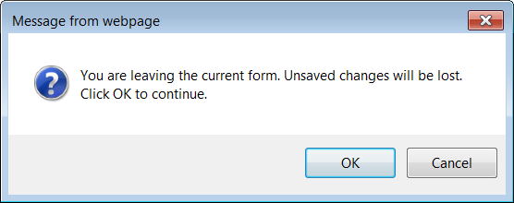
- If user clicks Cancel, the warning pop up is closed, no changes to the greensheet page.
- If user clicks OK, the system:
  - In case of Close button => the message pop up is closed, all unsaved changes are lost, the screen is closed.
  - In case of “Back to Grants List” link => the message pop up is closed, all unsaved changes are lost, Actor is taken back to Grants List screen (if possible, the list of grants is long, the focus should be on the grant from with Actor navigated. Will help when the list of grants is long).
